Student Number: 2152594

Student Name: Jodi Chapson

Assignment 1: Data Design MDA Analysis Essay

Game: Catan Universe

Word Count: 1427

Due: 29 March 2021 at 08:00

PLAGIARISM DECLARATION

1. I know that plagiarism is wrong. Plagiarism is to use another’s work to pretend that i is one’s own.
2. I have used author date convention for citation and referencing. Each significant contribution to and quotation in this essay from the work or works of other people has been acknowledged through citation and reference.
3. This essay is my own.
4. I have not allowed and will not allow anyone to copy my work with the intention of passing it off as his or her own.



1. I have done the word processing and formatting of this assignment myself, I understand that the correct formatting is part of the mark for this assignment and that it is therefore wrong for another person to do it for me.

Signature: Date:



This essay aims to dissect *Catan Universe* developed by Exozet, through usage of Hunicke, LeBlanc and Zubek’s (2004) MDA framework, with particular focus on data design. Firstly, the game’s various main components, such as its core mechanics and system, of which data forms a major portion, will be broken down and analysed. Secondly, the dynamics that rise from these data-heavy mechanics will be discussed. And finally, this essay will address how *Catan Universe*’s data design defines and supports its core aesthetics, and hence the overall player experience.

Data design deals with the all-important role played by data and numbers in games – as games at their cores are built on their numbers, data, and rules – and hence would not exist without them. Data affords designers a means of tangible control over their games during the developmental process. Data also provides clear communication of information, allowing for players to better make sense of game, resulting in more room for planning, strategy, and mastery, as is the case with *Catan Universe*.

*Catan Universe* developed by Exozet (2017), is a video game based off the popular boardgame *Catan* (previously known as *The Settlers of Catan*), originally designed by Klaus Teuber, and published by Kosmos in 1995. Players take on the role of settlers, focused on constructing their settlements, and monopolizing precious resources and limited land. To triumph over their opponents, be they players or computer AI, players must amass Victory points (VP), which are awarded for certain accomplishments (building infrastructure, having the longest road – or the biggest army). The first player to amass a certain amount of VP, wins the game.

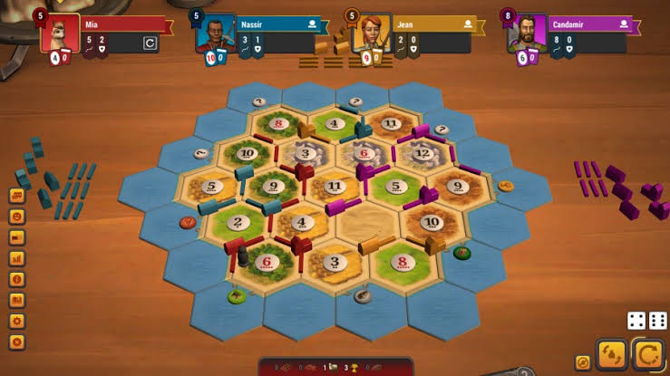Normally, *Catan Universe* is played with 3 – 4 players. There are a several board types with varying numbers of tiles and differing arrangements of said tiles. However, for the purpose of this essay, discussion will largely focus on the default board (see Fig. 1) that features 19 hexagonal tiles arranged in the shape of a large hexagon, surrounded by a ring of blue water tiles. Of those 19 tiles, 1 is a desert tile that is devoid of resources, while the remaining 18 are assigned a random resource at the beginning of the game, and a number between 2 – 12 (excluding 7). There are 5 possible resources in the base game – brick, lumber, wool, grain, and ore, used in building road, settlements, or cities, buying development cards or trading for other resources.

Figure 1: Default *Catan Universe* board.

At the beginning of each game, players can place settlements at the intersection of tiles – though settlements must have at least 2 road spaces between them. Aside from awarding VP upon being built, settlements (and later, cities) determine the resources a player has access to. At the beginning of each player’s turn, they must roll two 6-sided die, and the **sum** of the rolls will determine whether a thief is summoned (if a 7 is rolled) or which tile will bear resources (e.g. rolling a 6 will allow players with settlements adjacent no. 6 tiles to claim resources). This has the added consequence of different tiles having different chances of being rolled. Settlements reward 1 of a resource on a successful roll, while cities reward 2. Rolling a thief will result in a player losing resources (if they have 8 or more resources in hand) and allow the roller to sabotage, and subsequently steal 1 resource from another player.

There are also Development cards (which can be bought with certain resources) that offer random boons or one-time-use skills. In total there are 25, with only a certain number of each type. Once drawn or used, they are not put back again. Of the several types, one rewards a 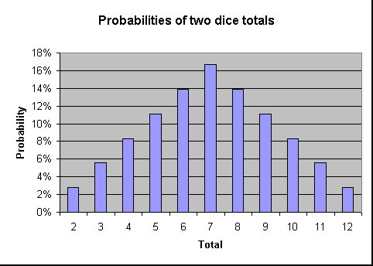victory point, one allows for manipulation of the thief, and the rest deal with obtaining resources, either from the board or other players. A player can only use one development card in their turn, and not in the same turn it was bought.

Finally, there is trading. Players can trade with each other, with the computer AI (if playing vs AI) or with the bank. While players can barter and haggle with one another, trading with the bank is quite strict. At the start of the game, players must trade 4 of the same resource, for 1 resource of their choice. Upon building settlements at ports (located along the outer edge of the board) players can gain access to more favourable deals.

Figure 2: Probabilities for all possible totals of rolling 2d6.

The aforementioned mechanics and rules of *Catan Universe* serve, in one way or another, the main goal of resource acquisition and management – as ultimately, access to and strategic usage of precious resources, on a highly contest board with limited space, will determine a player’s success.

As such, one of the main dynamics of *Catan Universe*, is strategy. Before the players, lies a board full of possibilities – spaces to conquer, resources to monopolise and goals to achieve. There is at once so much before them, but also so little – since space is limited and precious. There are many different paths to obtain Victory points, and hence, also many paths to obtain victory. Yet like the tiles of the board (see Fig. 2 above), not all paths may have the same chances of bearing fruit. Should players focus one achievement or resource, at the cost of neglecting another? Should players take upgrading to cities over building new settlements? Should they monopolize one resource, or try have a hand in all? What strategy is the best?

And even with a time-proven strategy, a game’s conclusion will always remain uncertain because of chance. Chance plays a large role in *Catan Universe.* The board is randomized at the start of each game – resulting in a new playing field each time. From different number of resource tiles, to differing chances of obtaining said resources – a large portion of a player’s success comes down to the roll of two die and the number they are given. The game becomes a matter of maximising one’s chances and options – of analysing the data of the board, studying the available numbers and information, and making a move. And since this is a player vs player game, there is also the uncertainty of the enemy – what will they do? What are their goals and strategies? And how can one foil them, or avoid being foiled? Such is the intense strategy found in *Catan Universe*.

It is no surprise then, that a main aesthetic of *Catan Universe*, would be Challenge. The game is rooted in complex strategy based off the data present in the board before the player, and the uncertainty posed by the 2 six-sided die in their hands. It is a long and intense competition between players. Resource gain is slow (particularly at the start) and difficult to guarantee. Every action requires great deliberation and careful planning – lest one squander one’s resources and give an advantage to the enemy. Long-term strategy is key, and every turn poses new challenges, to which the player must adapt.

A secondary aesthetic could be Fellowship. Even though *Catan Universe* is a competitive, strategy game between players, there are options for co-operation between players (even if only temporarily for mutual benefit) and interaction through trading and thief-juggling. Players can team up to sabotage another player, or simply assist one another.

A lesser aesthetic of the game could be Fantasy, as *Catan Universe*, though it does not have much lore or actual narrative, is careful set in the fantasy world of Catan, in which settlers (the players) settle down and compete for domination over resources and power. The board comes with little placeable settlements, cities, and roads, with cards for each resource. This aesthetic, and Fellowship, have less to do with the game’s data design than the main aesthetic Strategy, and deal with other areas of the game, such as player interaction and what game pieces represent story-wise.

At its core, *Catan Universe*, much like the boardgame on which it was based, is a competitive, strategy game in which data not only makes up most of the mechanical structure, but also is necessary for success in the game. It is through numbers and data, and a dash of chance, that the strict system of resource acquisition and management is formed in *Catan Universe* – a system central to every moment of gameplay in this game. In this essay, it is concluded that through strict and complex assignment of numbers, chances, and probabilities, *Catan Universe* came to be, and that data defines its dynamics of Strategy and ultimate aesthetic of Challenge.

Bibliography

Exozet. (2017). Catan Universe (PC Version v.2.2.1) [Video game]. Germany: United Soft Media.

Hunicke, R., LeBlanc, M., & Zubek, R. (2004). MDA: A Formal Approach to Game Design and Game Research.

Teuber, K. (1995). Catan (1st edition) [Boardgame]. Germany: Kosmos.